A Quokka Story

Design Document

Overview

Project Purpose
Create an emotionally engaging 2.5D Metroidvania platformer that raises awareness about quokka conservation while delivering innovative gameplay through music-reactive combat mechanics.

Target Audience
This experience is targeted at users who enjoy:
- Indie game enthusiasts who love Metroidvanias (Hollow Knight, Ori series) and appreciate unique game mechanics with emotional storytelling.
- Animal/Nature-Focused Games like Endling: Extinction is Forever, Spirit of the North, ABZÛ, Fe, The First Tree, Beyond Blue. Conservation message wrapped in engaging gameplay, cute protagonist.
- Lovers of Retro Platformer Nostalgia that enjoyed Donkey Kong Country, Earthworm Jim, Castle of Illusion, Aladdin (Genesis/SNES) for that 2.5D perspective evoking classic era with modern polish.

Elevator Pitch
"A Quokka Story is a Metroidvania where you rescue your stolen babies—then launch them as weapons to fight back. Each Joey has a unique ability with meaningful drawbacks: Lead Joey bowls through barriers but slows you down, GI Joey fires explosive bazookas but the backblast can damage you, Ninja Joey's shurikens ricochet between enemies but drain other Joeys' energy, and Ballet Joey's freeze pirouette controls crowds but makes you fragile. It's tactical baby-launching with genuine risk/reward decisions in every encounter."

Game Mechanics
Player as the Quokka Mom can eat, walk, run, jump, climb and launch Joey’s from her pouch.

Concept art
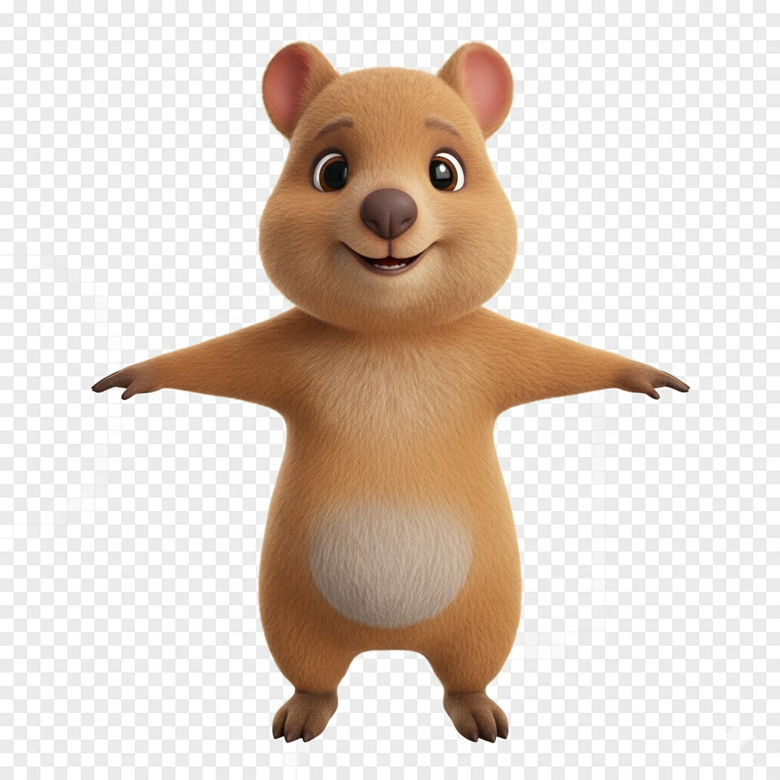Quokka Mom “Alinta”

Confirmed Joeys
Normal Joey 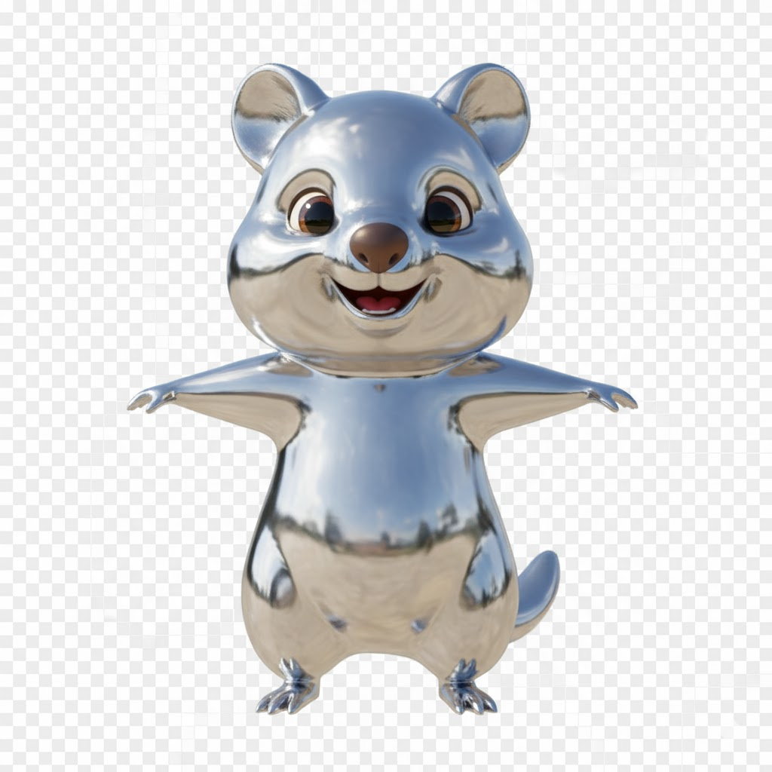Lead Joey
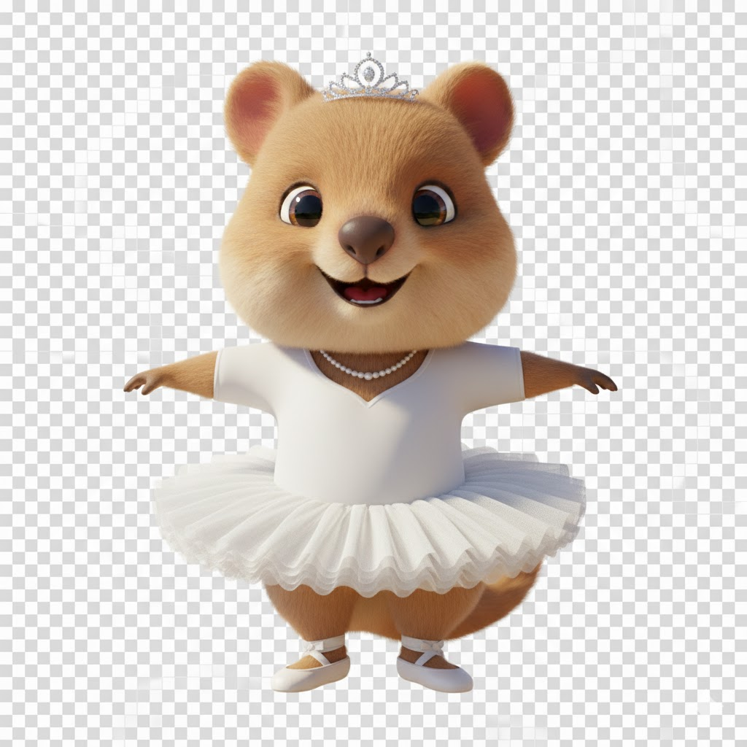Ballerina Joey 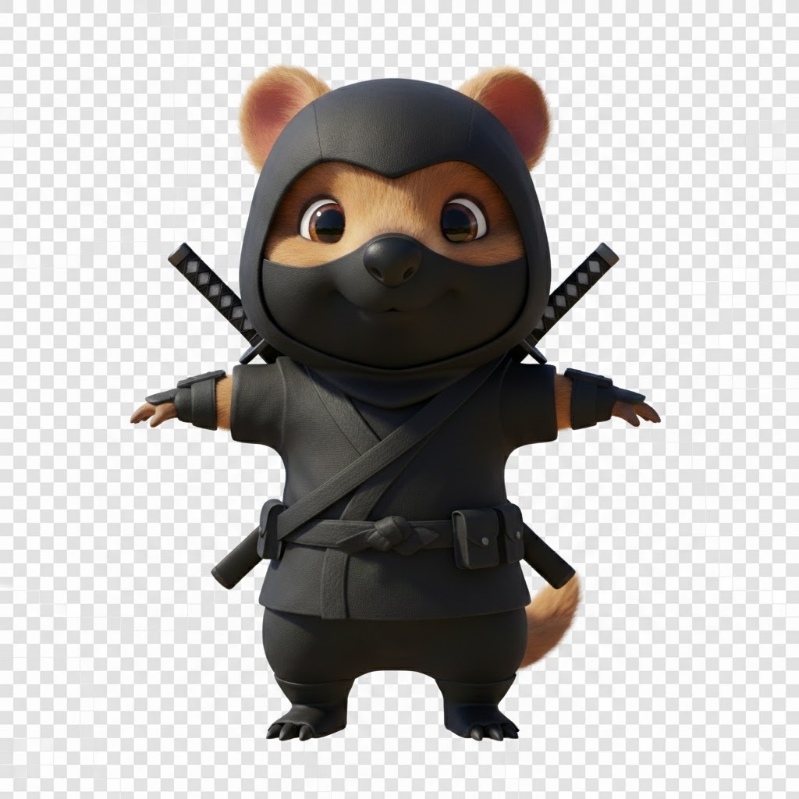Ninja Joey
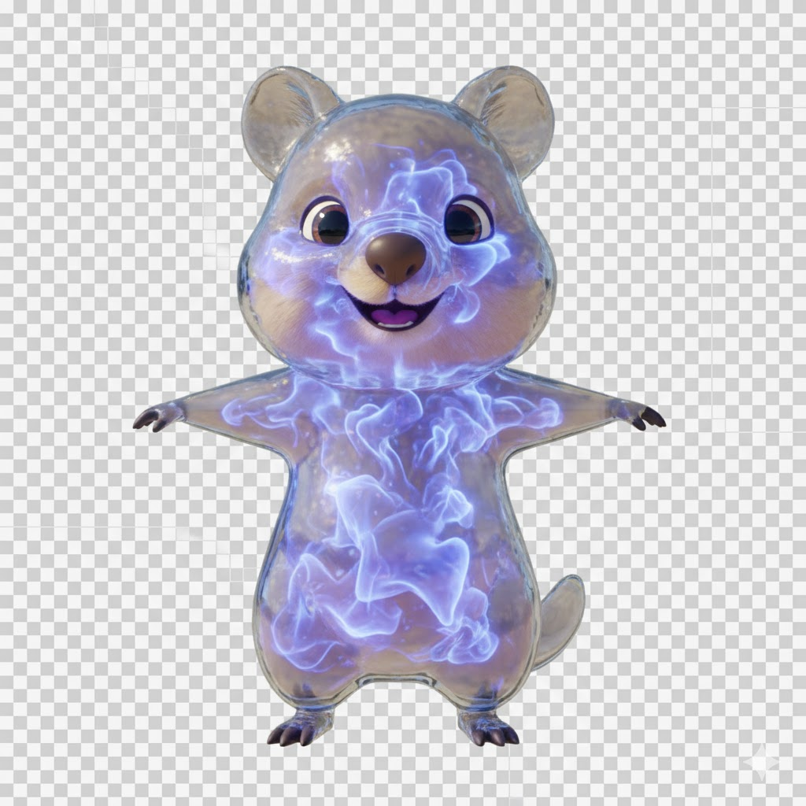Helium Joey G.I. Joey
Possible Backup Joeys
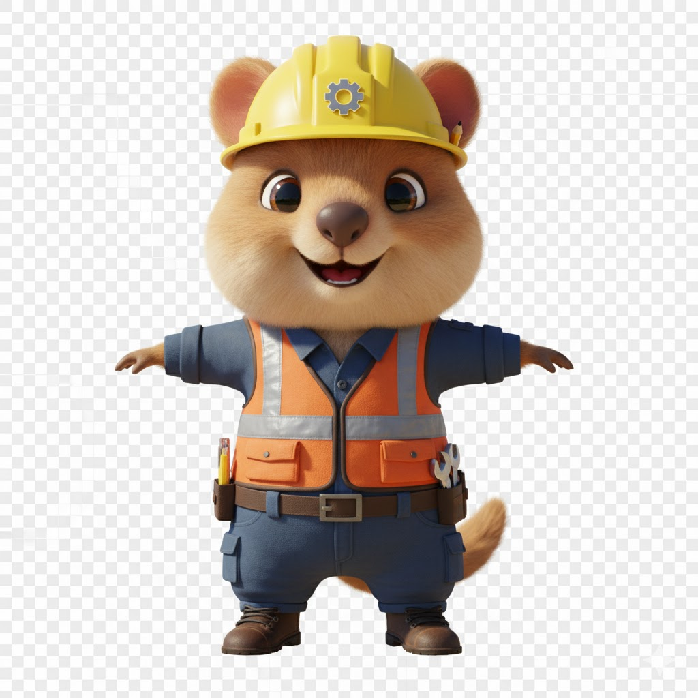Engineer Joey
Enemy reactions to Helium Joey


Reference examples
Inspiration came from songs, “Can’t find my way home” by Blind Faith(Steve Winwood), “Made up mind” by Tedeschi Trucks Band, “Day in the Sun” by Susan Tedeschi & Derrick Trucks, “Goodbye” by Joy Oladokun, and “I am the Fire” by Halestorm | Equipment system like Mega Man or Spelunky 2.  Gating system like Darksiders  Energy system like Risk of Rain 2.

Project Requirements
Shaders / Materials
Lighting
Animation
VFX
Cameras
Post-processing
Audio
UI

